Registration: Please print neatly & clearly
Name: _________________________________________________
NOTE: Teachers from the WRDSB can apply for ETFO Waterloo Region Membership Development Funding
($260.00 per year). Must apply before the course is held.

Teachers check your board’s membership ETFO funds.

Work Location: ___________________________________
Tel: ______________________ Cell: _____________________
Email: _________________________________________________
Check what you want:
______ Course A: Kids- Move Course: Thursday August 18, 2016 $140.00
______ Course B: Kids- Move Course: Sunday October 2, 2016 $140.00

______ Course C: Brain Gym Introduction: Wed. August 17, 2016 $125.00
(No Brain Gym colour poster)

______Course D: Brain Gym Introduction: Wed. August 17, 2016 $150.00
(Brain Gym colour poster included)
______ Course E: Brain Gym Introduction: Sun. Sept. 25, 2016 $125.00
(No Brain Gym colour poster)
______ Course F: Brain gym Introduction: Wed. August 17, 2016 $150.00
(Brain Gym colour poster included)
if registered before July 18, 2016
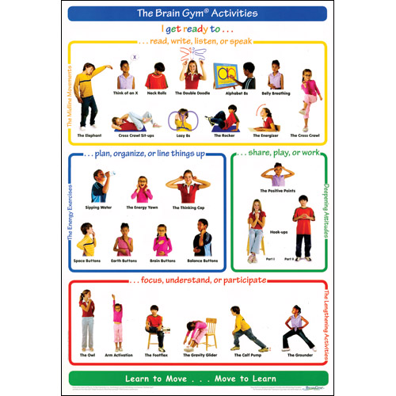
Special offer: Take 2 courses (without Brain Gym poster) for $250.00

Course ____ and course ____ (use letter of course please: A,B,C,D,E,F)

or
Special offer: Take 2 courses with Brain Gym coloured poster $275
(summer or fall courses)
Total Amount for course(s) sent is:
$____________________

Course ____ and course ____ (use letter of course please: A,B,C,D,E,F)

To E-Transfer, contact Liz Jones-Twomey at jonestwomey@rogers.com

To register, complete the form, include payment, and send to:
Liz Jones-Twomey 519-743-0181 home
100 Nipigon St. 519-590-0619 to text
Kitchener, ON N2B 3N7 or Email: jonestwomey@rogers.com
Check out my blog at www.kids-move.com

